Exercise 3.1

1) Transport layer protocol used in dns query is UDP.

2) Destination MAC address for ARP request/response is 00:00:00:00:00:00.

3) ICMP header type for Echo request: 8.
ICMP header type for Echo reply: 0.
Size of the data field is 48 bytes.
Data found in one of the packet is 7f86060000000000101112131415161718191a1b1c1d1e1f…

4) User-agent filed in http get request: Mozilla/5.0 (X11; Ubuntu; Linux x86_64; rv:50.0) Gecko/20100101 Firefox/50.0

5) Following are the filters used.

a) udp && not ntp && ip.src == 192.168.1.100

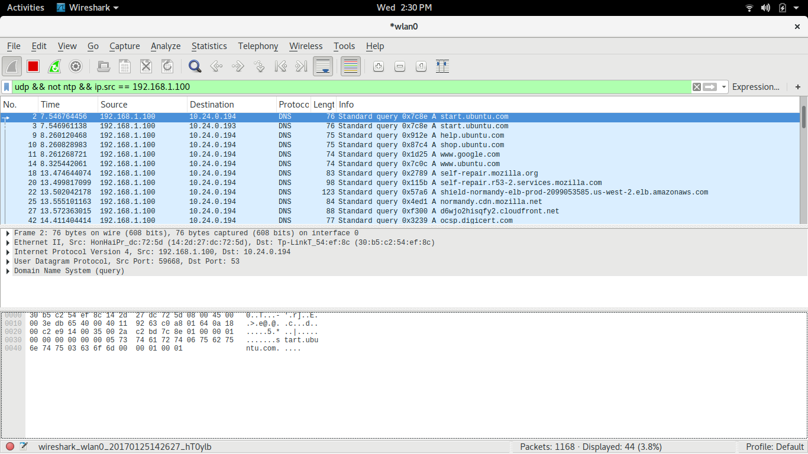

b) tcp && not ssl

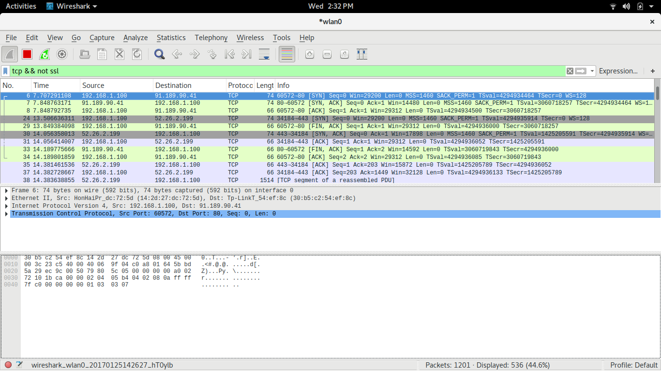

Exercise 2.4

A's IP address is set to 192.168.123.1 and B's IP address is set to 192.168.123.2 through GUI.
Netmask is set to 255.255.255.0, gateway in B is set to 192.168.123.1 and dns in B is set to 10.6.0.11.

Following are the commands used in A to allow packet forwarding:-
- sudo echo 1 > /proc/sys/net/ipv4/ip_forward
This command is used to enable IP forwarding.

- sudo iptables -t nat -A POSTROUTING --out-interface wlan0 -j MASQUERADE
This command is used to set the outgoing interface for ip forwarding. Here it is set to wlan0.

- sudo iptables -A FORWARD --in-interface eth0 -j ACCEPT
This command is used to set the incoming interface for ip forwarding. Here it is set to eth0.

Exercise 3.2

- Abhik 10.6.15.92 and Bob 10.22.21.249. First message is "Hi Abhik!" and last message is ":)".

- The file is splitted into 10 packets. The type of the file is jpeg.

- Watch Dogs is the game, Bob was taking about.

